Morningstar May Update
Economic and market round-up
- Persistent themes: inflation, slowing growth, interest rate rises, lockdowns in China and the ongoing war in Ukraine all continue to weigh on market sentiment. Given this continuity, most equity markets ended the month broadly flat, although intra-month turbulence was high in some areas. The US stock market (S&P 500) suffered its worst 1-day fall (4%) since June 2020 on 18th May. Fears were stoked after large retailers, including Target and Walmart, cut profit guidance, citing increased cost pressures and consumer sentiment, leading to wide-spread concerns over an economic slowdown. The subsequent rally towards the end of May can be attributed to oversold conditions and speculation of a less aggressive stance from the Fed regarding rate rises.
- Inflation control Vs. slowing growth: central banks continued their attempt to stem inflation by increasing interest rates: the UK central bank raised the based rate by 25bps to 1%, the US Fed raised rates by 50bps to range of 0.75% - 1%, and the European central bank indicated that the first rate rise would be in July. UK inflation reached 9% year-on-year in May, with similar levels in Europe and the US, far more than the 2% target. Pressure is on central banks to get inflation back in check, but given that raising rates has the effect of dampening business investment and cooling demand for goods and services (all else being equal), slowing economic growth is also in focus.
- Bond markets “normalising”: following an extended period of being expensive, bonds saw their worst quarter in over 20 years in early 2022. Global government bonds have fallen over 11% this year, with the hardest hit being long-term bonds, owing to their greater sensitivity to interest rate changes (higher duration). Over the month, US bond yields fell (prices rose) as investors sought safer assets given economic concerns. Conversely, yields in the UK and Europe rose (prices fell) given fears over inflation and interest rate moves being the overriding concern.
- Valuation driven: market movements have been extreme so far this year. For example, value stocks further widened the gap between their growth counterparts in May, with outperformance of around 4%, taking the year-to-date outperformance to around 19%. This has been largely driven by value-dominated sectors such as energy and financials. Nevertheless, value stocks continue to look undervalued compared to growth stocks when looking at relative forward P/E ratios (long term average relative forward P/E 0.72 (since 1997) compared to 0.57 as at 31 March 2022). In addition, rising interest rates and high commodity prices should continue to favour this trend. Similarly, despite the pullback in US equities, we believe they remain slightly overvalued (as demonstrated by the chart below).

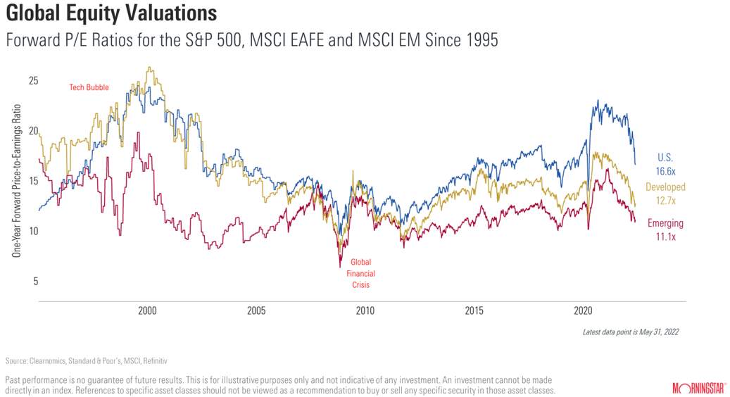

Performance

- The Morningstar Multi–Asset Funds continued to outperform the sector average in May, with all three funds delivering a positive return against a difficult market backdrop (0.14%, 0.41% and 0.75% for the MA40, MA60 and MA80 respectively). As a result, all three funds move up the rankings this year (to end May), with the MA40 fund ranking 30th percentile in the IA Mixed 20-60% Shares peer group and MA60 and MA80 ranking 13th and 8th percentile in the IA Mixed 40-85% shares peer group. Over the past 12 months the funds rank in the 33rd, 17th and 8th percentile (MA40, MA60 and MA80).
- The Morningstar Managed Portfolio suite compared well against competitors over the month and year-to-date with most portfolios across the Active, Passive, Income and Governed ranges outperforming their relevant ARC PCI*. Longer term numbers also compare well against the ARC PCI, with Moderately Cautious through to Adventurous portfolios outperforming over three and five years.
- From an equity perspective, our preference towards energy and financial sectors continued to positively impact returns, largely attributed to oil prices continuing to rise amid supply and demand imbalances, while banks tend to benefit from a rising rate environment. The volatile environment creates opportunities and we have been taking profits from the energy sector to invest the proceeds in areas that offer better value, such as European financials, Germany and China. For our bond exposure we continue to favour emerging-market debt, in local currency, which benefitted returns over the month, owing to a rally in EM currencies.
*Asset Risk Consultants Private Client Indices

Outlook

- Investors have been taken on a wild ride so far in 2022, and the future holds a wide range of possible outcomes. Accepting volatility is a prerequisite for good returns in any market, but today’s market arguably requires greater care than usual. Our role as investors is to construct portfolios that empower people to reach their goals whatever the economic and market conditions. In every situation, the right approach is to view the future probabilistically and think long term.

