Dampening UK outlook
25th May 2022

Relative to its historic lacklustre performance, the FTSE 100 has started the year promisingly versus other global indices. Whilst this performance was initially buoyed by the market rotation at the start of the year, it has since been driven higher by the war in Ukraine and its impact on energy and commodities, to which the FTSE has significant exposure.

UK stock markets vs other global indices
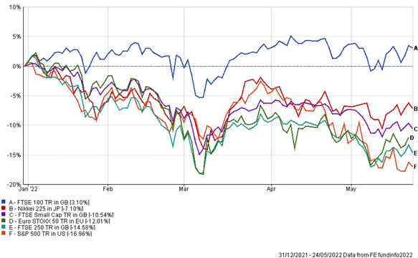
Source: FE Analytics

As seen above, this has meant the main UK index is the only one out of the US, Europe and Japan to be in positive territory year-to-date (YTD). However, whilst stock market returns have shown promise, the outlook for the economy itself is not looking so rosy and there is a real risk of stagflation (rising inflation and stagnant economic growth) rearing its ugly head. Sentiment towards this can be seen by looking at the FTSE 250 or FTSE Small Cap index, which are more accurate reflections of the health of the UK economy and are both down so far YTD.

Inflation
It seems appropriate to first look at inflation, as this has grabbed the mainstream headlines and has significant knock-on effects for the economy. UK CPI jumped to 9% in the 12 months to April, a 40 year high^{[1]}. This came from the removal of the energy price cap last month but was also stoked higher by the inflationary aspect from the war in Ukraine and other supply chain disruptions caused by Brexit and the COVID-19 lockdowns in China. None of those factors seem to be abating any time soon and the energy price cap looks set to be increased again in October by another 54% according to Ofgem. To put the recent CPI reading into perspective, the UK now has the highest rate of inflation of any G7 country.

The UK is a large net importer of goods and much more reliant on them than its counterparts across the pond and on the continent, meaning the economy is susceptible to exchange rate swings and thus inflation. Moreover, as the economy’s outlook turns bleaker, pound sterling does not look as attractive for investors, as it is typically viewed as a proxy for relative macroeconomic performance.

Labour market
The labour market in the UK is incredibly tight – there are currently more job vacancies than unemployed people. This is partly because many people dropped out of the labour market during the pandemic; although, this trend may reverse as the cost of living crisis pinches on the purse strings and might make some people reconsider their retirement plans. Another factor continues to be the impact Brexit is having on sourcing people to fill said job vacancies.

A concern is that if inflation persists, as currently expected, then the labour market tightness may lead to a wage price spiral – that is, employees demand higher wages, which companies aim to offset by hiking their prices further. A spiral can also be instigated as companies seek people to fill those positions and are forced to pay above the odds to secure the talent.

Fewer Britons aged 50-64 are choosing to work
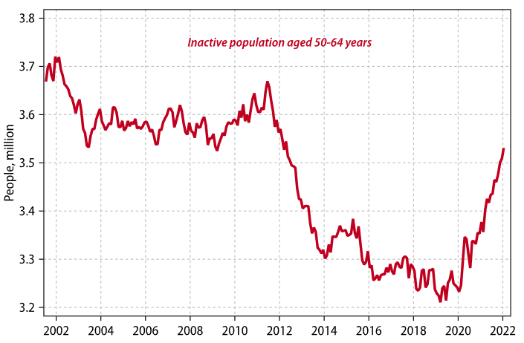
Source: Gavekal Research / Macrobond (13/05/2022)

Monetary policy
The Bank of England was the first out of the US and Europe to hike interest rates in an attempt to combat rising inflation. They are clearly trying to balance a very tight labour market with the rising cost of living crisis. The tight labour market risks wages rising materially higher. On the other hand, given the rise in energy costs, they now forecast inflation to peak above 10% in the fourth quarter of this year. Ideally, the BoE would like to support households and the economy, but it is also attempting to ease inflationary pressures whilst maintaining real incomes, which would constrain consumer spending.

Overarching impact
Recession risk has clearly risen across all markets over the last few months as energy prices act as a dampener on demand. However, we feel this risk is particularly acute in the UK; the combination of having the labour tightness of the US plus the energy crisis of Europe, along with Brexit implications is a serious headwind for the UK economy. These factors are having a negative impact on many macro data points and a technical recession in the second half of the year presents a real risk.

The GfK Consumer Confidence indicator in the UK hit a record low of -40 in May, surpassing the previous record low of -39 set in July 2008^{[2]}. Put another way, at this time consumers in the UK feel we are in darker days than the global financial crisis, the impact of Brexit on the economy, and the COVID-19 lockdown.

UK manufacturing Purchasing Managers’ Index (PMI) fell to a 16-month low on Tuesday – although by coming in at 54.6, it is not yet in contractionary territory^{[3]}. Brexit-related trade friction and ongoing supply chain disruptions are cited as the main drags. Likewise, the services PMI data came in at a 15-month low of 51.8^{[4]}.

LGT WM Portfolios
Whilst a gloomy and rather pessimistic read, we have been aware of these factors for some time and have been proactive in the portfolios to counteract any short to medium term effects. Firstly, we have been moving more global with our portfolios over time but have also made some recent tweaks in response to the dampening outlook for the UK.

As noted, recession risks have risen, particularly in the UK, where consumer balance sheets are weaker than the US and consumer sentiment has weakened. UK fiscal policy has also moved to being more contractionary, both with higher taxes and less appetite to offer support for households. As such, we removed our exposure to the Jupiter UK Smaller Companies fund, a fund with outsized exposure to the UK domestic economy. This is a fund that we reduced exposure to at the beginning of April, but we have now fully closed out the position across all risk levels.

It is also worth mentioning the top UK-listed holdings in the LGT WM Balanced portfolio, all of which are large, global companies who are more sheltered from a slowing economy than those who derive their revenue solely on these shores, such as those held in the Jupiter UK Smaller Companies fund. They are also in line with our house view of holding high quality companies and if you align this with the fact they are of a more defensive nature, then we are comfortable with our positioning in the UK equity space.

Company |  | Holding Size % |  | Sector
RELX |  | 1.35 |  | Communication Services
Unilever |  | 1.09 |  | Consumer Defensive
Diageo |  | 0.74 |  | Consumer Defensive
AstraZeneca |  | 0.51 |  | Healthcare
GlaxoSmithKline |  | 0.49 |  | Healthcare
Reckitt Benckiser Group |  | 0.43 |  | Consumer Defensive
Sage Group |  | 0.42 |  | Technology
London Stock Exchange Group |  | 0.39 |  | Financial Services
Experian |  | 0.35 |  | Industrials
Burberry Group |  | 0.32 |  | Consumer Cyclical

Source: Morningstar

Important information
This communication is provided for information purposes only and is intended for the exclusive use of the recipient to whom it has been directly delivered by LGT Wealth Management UK LLP and is not to be reproduced, copied or made available to others. The information presented herein provides a general update on market conditions and is not intended and should not be construed as an offer, invitation, solicitation or recommendation to buy or sell any specific investment or participate in any investment (or other) strategy. Past performance is not an indication of future performance and the value of investments and the income derived from them may fluctuate and you may not receive back the amount you originally invest
Although this document has been prepared on the basis of information we believe to be reliable, LGT Wealth Management UK LLP gives no representation or warranty in relation to the accuracy or completeness of the information presented herein. The information presented herein does not provide sufficient information on which to make an informed investment decision. No liability is accepted whatsoever by LGT Wealth Management UK LLP, employees and associated companies for any direct or consequential loss arising from this document.
LGT Wealth Management UK LLP is authorised and regulated by the Financial Conduct Authority.

