Fortune favours the bold
11th May 2022

Recent market moves
Markets started this week off with an aggressive downturn. The S&P 500 fell by a sizeable 3.20% on Monday, taking the index to its lowest level in over a year^{[1]}. That follows on from five consecutive weekly losses, which is already the longest run in over a decade. Whilst markets found some footing on Tuesday, it would take an impressive reversal to dodge extending that run to six weeks. Onto the NASDAQ, and the last time we saw this level of decline was in April 2020 at the height of the COVID-19 drawdown (see chart below). Although, in 2020 this occurred over a mere few days, rather than months. Nonetheless, it adds some perspective to the drawdown.

NASDAQ performance
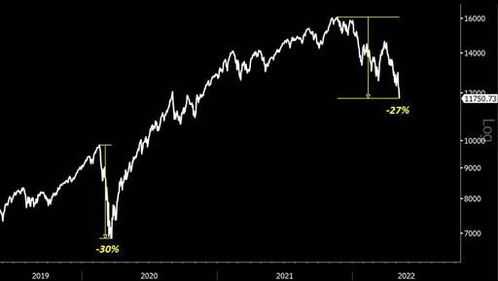
Source: Bloomberg (09/05/2022)

A change in investment landscape
When we saw the last significant drawdown in 2020, the Federal Reserve (Fed) was incredibly supportive of its domestic stock markets. This time around, they have little choice but to continue tightening monetary policy (hiking interest rates), with inflation still running rampant, spurred on by the war in Ukraine and backlog at Chinese ports from its government’s incessant need for zero-COVID. They are very much stuck between a rock and a hard place, and it seems as if that rock is only getting larger and harder to manoeuvre. This, combined with the dampening global growth outlook, has sent markets into unrelenting tailspins over the last month or so, and volatility has been incredibly high.

Inflation peaking?
US inflation looks likely to peak in the short-term. Month on month, core inflation numbers peaked in April, May, and June 2021 and these will drop out of the year-on-year calculation over the coming months. Used car prices, the poster child of COVID-19 inflation, where aversion to public transport and migration to less urban areas caused a spike in demand, are now falling. Conflict in Ukraine, de-globalisation and tight labour markets will likely keep inflation volatile and higher than pre-COVID level at year-end, but declining rates of core inflation should hopefully improve investor and consumer sentiment.

Soft landing?
Taking stock markets out of the equation for a moment, the Fed attempting to rein back in inflation could ultimately result in a recession, but they will be hoping for a ‘soft landing’ – i.e. a period of monetary tightening not concluding in a recession. In 12 major tightening cycles since 1954, the Fed has managed to raise interest rates significantly without leading to a recession on only three occasions: 1965, 1984 and 1994^{[2]}. Investors will hope for another occurrence, but a few factors will need to budge if so. That is, there needs to be some clarity on the situations in both China and Ukraine, and wage growth needs to slow. The Fed can only control the latter by hiking rates to reduce labour demand, such that job vacancies roughly equal the number of people out of work. In doing so, Chair Jerome Powell hopes this will suppress wage pressure, whilst also putting the brakes on inflation.

Some positivity
Very little is performing well at the moment, Monday saw a broad-based sell-off for example, so we must try to be optimistic and focus on the light at the end of the tunnel. When the tunnel ends is notoriously difficult to predict in markets, but what we can do as money managers is hold a balanced and robust portfolio of asset classes. We have been active in removing some of the biases in our portfolios in recent months – please refer to recent performance document for more information.

To provide a spot of optimism, stocks are currently ‘on sale’ from their previous highs – have the underlying businesses really changed though? The recent results season was a mixed bag but there were some solid results in there, just on tough comparisons. Some of the names in our portfolios are now trading some distance from their all-time highs – Alphabet (-25.7%), Adobe (-46.1%), Amazon (-42.3%), Microsoft (-24.3%) and Apple (-16.9%) – but these are still high-quality businesses with pricing power, and strong economic moats.

So, if we are able to ride out this period of volatility, with our lower risk assets providing some downside protection such as Ruffer Diversified Return, then what awaits us at the other side is our fund managers who have been picking up bargains in these dark times and those should start to reap rewards once markets begin to find some footing. It’s not often these discounts come by, but when they do fortune favours the bold.

