We wanted to get in touch to give you a market update, given the extreme volatility we have experienced since the start of the year. Since January, pessimism has intensified which has seen all the main asset classes sustain losses, fuelled by a mix of rising interest rates, the horrendous Russian invasion of Ukraine, and persistently high inflation. Fortunately, weak sterling has offset some of the losses in global equity markets for UK investors, but the year‐to‐date performance of major markets has been challenging as shown below.
Of the major equity market indices, the US market has been the weakest, with the S&P 500 Index (comprising the largest 500 US companies) falling c.18% and the NASDAQ Composite Index (comprising mostly technology stocks) falling c.27% this year on a total return basis and hitting a low on Thursday 12th May. In fact, more than half of the NASDAQ Index’s holdings have fallen by more than 50% since the beginning of the year. Much of this weakness can be attributed to the rising interest rate environment, given the US Federal Reserve’s attempts to subdue inflation. For smaller, early-stage businesses that are not yet profitable, it will become more expensive to raise capital to achieve sufficient scale and reach profitability. However, this is not necessarily an issue for some of the largest constituents of the NASDAQ Composite, including Apple, Alphabet (ie. Google), Microsoft and Amazon, which have solid balance sheets and been profitable for many years. For example, Microsoft has more than $130bn of cash on its balance sheet, with earnings per share expected to rise by c.16% pa over the next three years. We continue to prefer asset-light businesses with strong balance sheets, high profitability, recurring revenue and the ability to pass inflation on to its customers.
After years of underperformance, it is the FTSE 100 Index that has been remarkably resilient, falling by just c.5% (total return) over the same period. This strength can be ascribed to the FTSE’s large exposure to industries such as oil & gas, financial services, banking and mining, which have benefitted (to varying degrees) from higher commodity prices and rising interest rates. As ever, these sectors remain beholden to the business cycle, typically have less capital discipline, low profit margins and weak balance sheets, with less consistent earnings.
Sentiment remains very weak. Since Russia invaded Ukraine, anxiety about inflation has picked up, meaning the odds have gone up that the January peak in equity prices could mark the top of the bull market cycle. Oil and gas prices remain at heightened levels and much of the global economy remains dependent on fossil fuels to function (see chart below). In Europe, this is particularly pronounced in Germany, which in December 2021 imported 32% of its natural gas requirement from Russia. This has highlighted the importance of energy independence and the need for countries to diversify energy sources. In the medium to long term, this should favour nuclear power and renewable energy sources, which generate energy domestically and have lower carbon footprints. We remain positive on the renewable energy sector and feel that high oil prices make the economics of renewables more favourable. Time will tell whether the oil and gas sector has learned the lessons of the past. Previously, high oil prices typically generated shareholder demand for oil majors to invest in expensive oil and gas exploration projects, usually culminating in a glut of supply. However over the next few years, global oil demand is expected to decline by c.4% annually. Furthermore, shareholder pressure is convincing boards to redirect recurring revenue into developing renewable energy projects instead. This could mean that higher oil prices could remain at higher levels for longer.

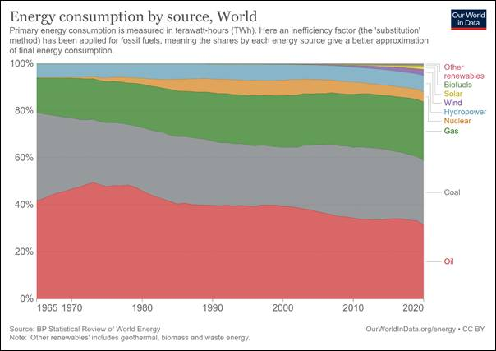
Brent crude pri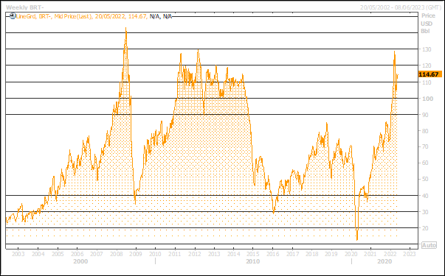ce (USD) per barrel over 20-year period (chart above)
However, there are signs that equity markets could be on the cusp of recovering to post a new cycle high, or at least stage a bear market rally. To achieve this, we will need to see several of the following scenarios occur:
- Inflation and interest rates
First, signs need to emerge that inflation is beginning to ease. Among these, the cooling of the housing market is crucial. The latest data from the Shiller US House Price Index surged the most on a month-by-month basis this cycle, and high house prices usually result in higher rent inflation. Investors will want to see that house prices moderate over the next few months. This may well happen, as interest rate rises start to restrict affordability criteria.
Another reason for inflation is the labour market (which is particularly strong in the US and UK). If we see a rise in labour force participation, this will help to ease inflationary pressure. As the restrictions from the pandemic gradually end, older workers who have removed themselves from the labour market in recent years, may well return. This often happens as the economic expansion matures and higher wages attracts more people back to work.
Finally, we need the supply chain to recover further. This requires improvement in oil and gas supply, as well as an easing of China’s zero-COVID policy. The good news is that globally, oil production is now exceeding consumption. Furthermore, China’s latest COVID outbreak is easing. While a return to normal will not happen immediately, the Chinese authorities have pledged to ease restrictions in Shanghai. China’s economy is also adapting by taking steps to ease supply bottlenecks in key sectors such as trucking.
If we get positive developments on the inflation front, this will allow central banks to raise interest rates more gradually. This in turn means that bond yields will rise more slowly, thereby limiting the downward pressure on equity valuations.
- Economic resilience
If the global economy can still grow at a time when commodity prices are high and interest rates have gone up, this would give investors more confidence that we are not going into a long-drawn-out recession. The US consumer has seen the biggest six-month rate rise since the early 1970s. While it is accepted that this will cause housing market activity to slow, investors will not want activity to drop sharply. The good news is that housing related surveys for April suggest activity so far has been resilient. Also, real wages for households could start to improve. The demographic of lowest paid workers (most vulnerable to the rising cost of living) has experienced the highest level of wage increases. Furthermore, many households have built up savings which they can draw down on amid the cost-of-living crisis.
- Financial stress constrained
We need to see that rising interest rates do not lead to a major increase in financial stress. While conditions have worsened, the data is still much better than during the financial crisis and the pandemic.
- An end to the war in Ukraine
An end to the war in Ukraine and ideally a complete Russian withdrawal, would help to ease pressure on the price of oil and gas. It would also allow soft commodities, including wheat and barley, to flow more freely through the global system. While we appreciate that sanctions between the West and Russia are unlikely to be removed all together, it would likely pave the way for a gradual improvement in relations, which in time could allow goods to flow more smoothly through the system (such as allowing Western freight planes to travel over Russian air space). This in turn may see companies refrain from hoarding more inventory, thus freeing up supply chains further.

With such negative sentiment and lower equity valuations, it would not take much for equity markets to rise from current levels. That said, we expect that volatility will continue to be a key theme. It is therefore vitally important that we look through the noise and focus on generating returns over the longer-term. As ever, we are very happy to have a chat with you at any time to review the constituents and our overall investment strategy for the portfolio.

“Bull markets are born on pessimism, grow on scepticism, mature on optimism and die on euphoria.”
Sir John Templeton

